Class Time:
Names:
Discrete Random Variables: Discrete Distribution Lab I

Student Learning Outcomes:
- The student will compare empirical data and a theoretical distribution to determine if everyday experiment fits a discrete distribution.
- The student will demonstrate an understanding of long-term probabilities.
Supplies:
- One full deck of playing cards
Procedure
The experiment is to pick one card from a deck of shuffled cards.

- What is the theoretical probability of picking a diamond from a deck? ___________
- Shuffle a deck of cards.
- Pick one card from a deck of shuffled cards.
- Record whether it was a diamond or not a diamond.
- Put the card back and reshuffle.
- Do this a total of 10 times.
- Record the number of diamonds picked.
- Let X = number of diamonds. Theoretically, X ~B( ____,____)

Organize the Data
1. Record the number of diamonds picked for your class in the chart below. Then calculate the relative frequency.

X | frequency | relative frequency
0
1
2
3
4
5
6
7
8
9
10

- = _______
- s = _______

- Construct a histogram of the empirical data.
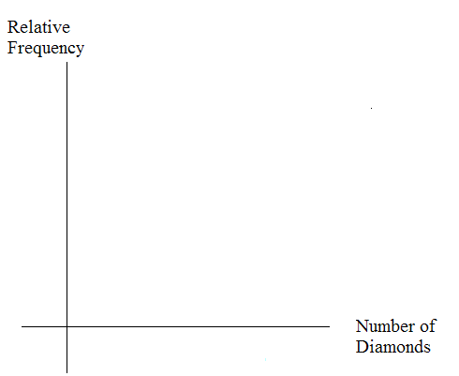
Theoretical Distribution
1. Build the theoretical PDF chart for X based on the distribution in Part I.
x | P(X = x)
0
1
2
3
4
5
6
7
8
9
10
2. Calculate the following:
- μ = __________
- σ = __________
- Construct a histogram of the theoretical distribution.
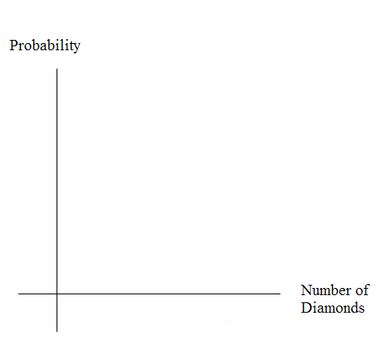
Using the Data:
Calculate the following, rounding to 4 decimal places:
NOTE: RF = relative frequency
Use the table from the section titled “Using the Data” here:
- P(X = 3) = __________
- P(1 < X < 4) = __________
- P(X ≥ 8) = __________
Use the table from the section titled “Organize the Data” here:
- RF(X = 3) = __________
- RF(1 < X < 4) = __________
- RF(X ≥ 8) = __________
Discussion Questions
For questions 1. and 2., think about the shapes of the two graphs, the probabilities and the relative frequencies, the means, and the standard deviations.
1. Knowing that data vary, describe three similarities between the graphs and distributions of the theoretical and empirical distributions. Use complete sentences. (NOTE: These answers may vary and still be correct.)

2. Describe the three most significant differences between the graphs or distributions of the theoretical and empirical distributions. (Note: These answers may vary and still be correct.)

3. Using your answers from the two previous questions, does it appear that the data fit the theoretical distribution? In 1 - 3 complete sentences, explain why or why not.

4. Suppose that the experiment had been repeated 500 times. Which table would you expect to change (and how might it change)? Why? Why wouldn’t the other table change?

